1. Three Popular Apps and Their Cloud Service Models
App | Similar to | Reason
Instagram | SaaS | Users directly access Instagram through an app or website without managing servers, storage, or software infrastructure.
Spotify | SaaS | Spotify provides a ready-to-use music streaming application. Users simply use the service without managing the underlying infrastructure.
Zomato | SaaS | Zomato is a ready-to-use application for ordering food and discovering restaurants. Users don't need to manage the software or servers behind it.
Note: In practice, these apps are large cloud-native systems that may use IaaS, PaaS, and other cloud services internally. For this question, they are most similar to SaaS from the end user's point of view.

2. Comparison of IaaS, PaaS, and SaaS
Point | IaaS | PaaS | SaaS
Meaning | Infrastructure as a Service | Platform as a Service | Software as a Service
What it provides | Virtual machines, storage, networking, etc. | Platform and tools for developing and deploying applications | Ready-to-use software/application
User manages | OS, applications, data, and configurations | Mainly application code and data | Mostly just application settings and data
Level of control | High | Medium | Low
Example | AWS EC2 | Google App Engine | Microsoft 365 / Office 365
Example use | A company creates a virtual server and installs its own software | A developer uploads application code without managing the underlying servers | A user opens Word Online and creates documents without installing/managing the software

Easy way to remember:
- IaaS → Rent the infrastructure
- PaaS → Rent the development platform
- SaaS → Use the finished software

  - Sign up for a free AWS account (or use an existing one), navigate to the EC2 dashboard, and launch a new t2.micro EC2 instance running Ubuntu 22.04. Take a screenshot of your running instance in the AWS console.<br><br><em><strong>Hint:</strong> Use the 'Launch Instance' button and select the free tier eligible Ubuntu AMI.</em>

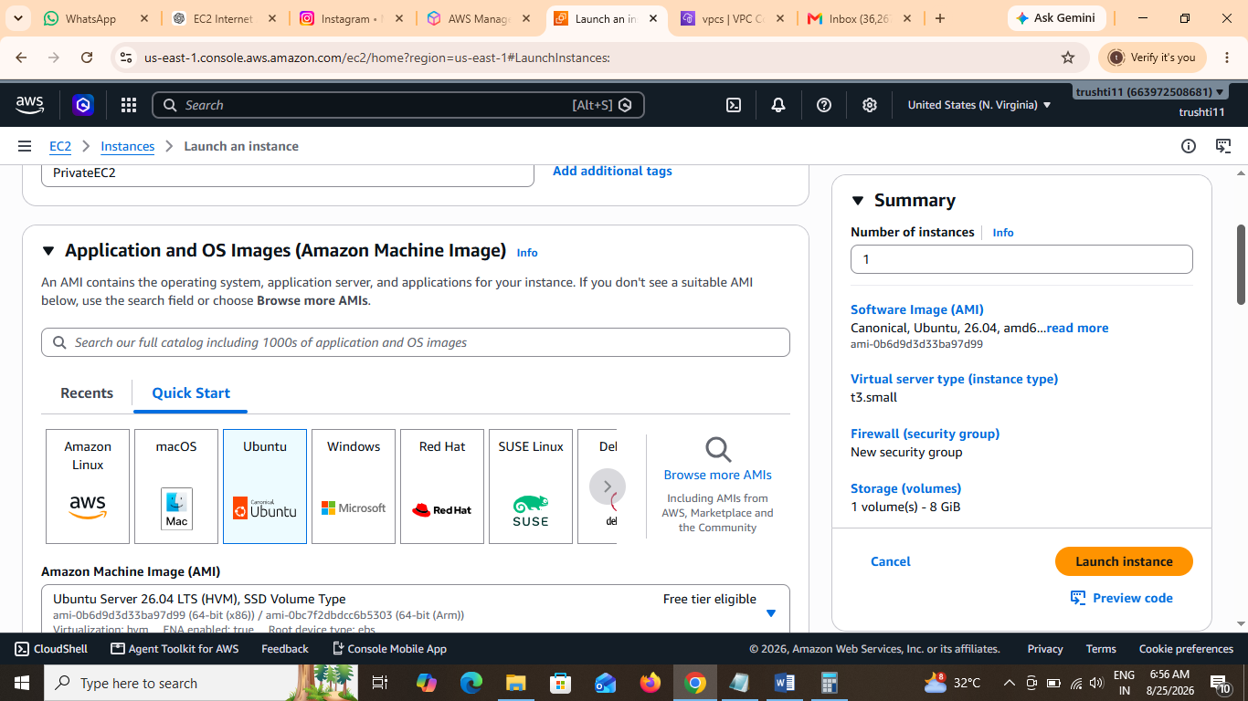
4.Run ‘Uname -a’ command in SSH after connection.
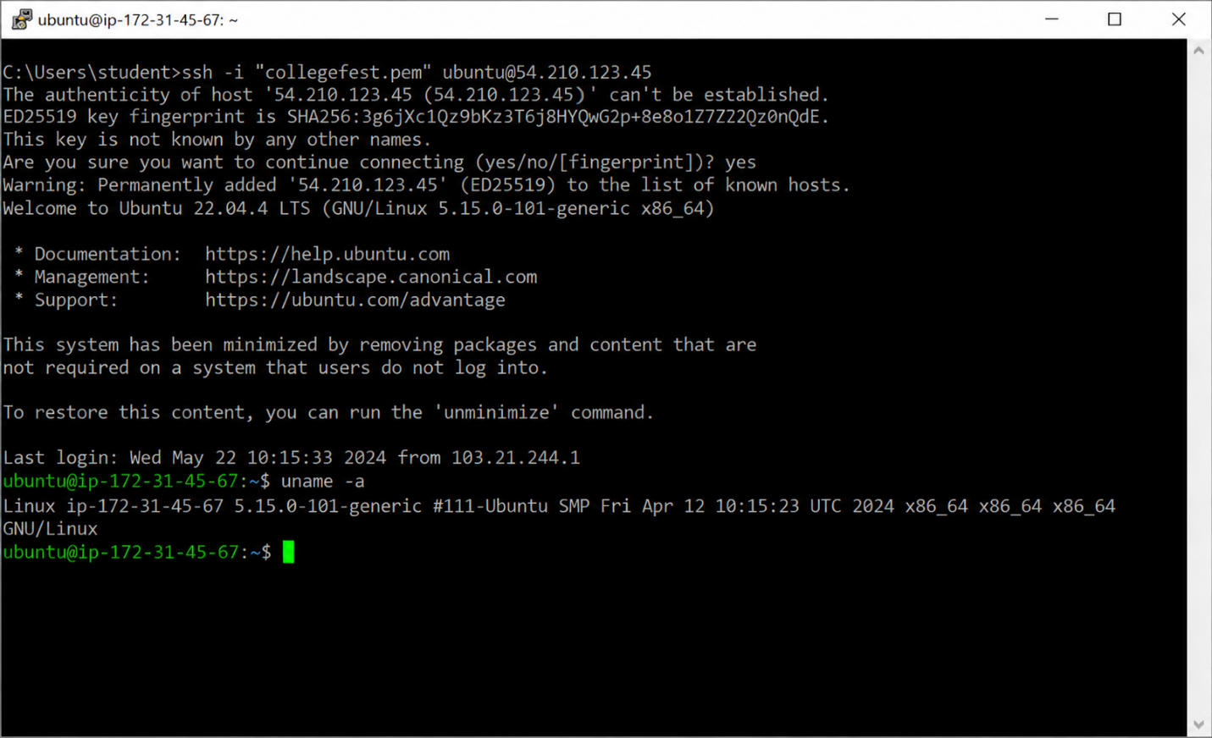

5. Hosting a Static Website on an EC2 Instance
After launching an EC2 instance, the basic steps are:
- Connect to the EC2 instance using SSH and update the packages.
- Install a web server such as Apache or Nginx.
- Create/upload your website files (for example, index.html) into the web server's document directory.
- Allow HTTP (port 80) in the EC2 instance's Security Group.
- Open the instance's Public IPv4 address in a web browser to access the college fest website.

